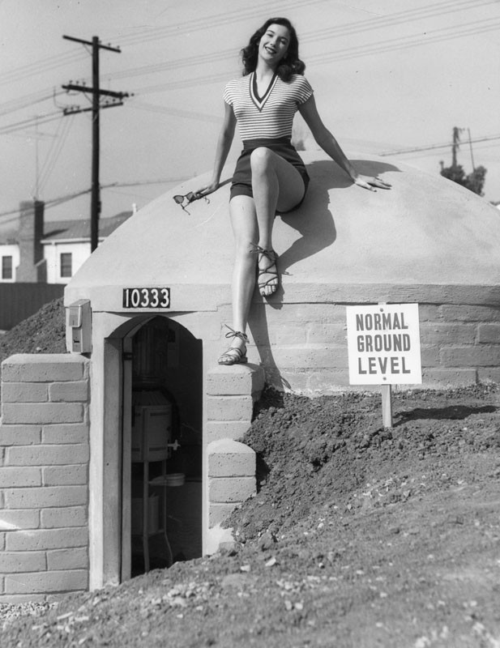

HIST 354: American Social History from 1940

Instructor: Stephen Buono

Email: buonos@indiana.edu

Welcome to American Social History since 1940, a course in which we’ll explore how Americans of all stripes—racial, ethnic, religious, generational, and sexual, among others—related to one another after World War II. As the word “social” implies, this is primarily a class about *people*. It attempts to uncover why people behaved the way they did in Cold War America; what they fought for and why; who and what they loved; what they did in their spare time; the things they agreed and disagreed about; and how their relationships changed over the course of sixty years. Major themes for this course include, for example: the unmooring of people from traditional sources of social affiliation such as the church, the family, the state, and community groups; sexual liberation and its discontents; the politics of consumption in American society; the impact of new technologies on social relations; and the ascendance in the 1950s and 1960s of new rights for women, African Americans, immigrants, workers, native peoples, gay people, and the disabled.

Most class periods will be divided into two parts. The first 40 to 50 minutes will be conducted in a traditional lecture format. Taking notes during this portion of class will help you succeed on the final exam. During the remaining time—again, 40 to 50 minutes—we’ll discuss the readings for that day, which appear in this syllabus below the corresponding date.

This is a fast-paced course. We’ll be meeting every weekday for three weeks and covering a substantial amount of material. It is therefore incumbent on you to complete the necessary readings before each class period, to study well in advance for the final exam, and to work vigilantly on the term paper (see below for details about these assessments).

**Required Readings**

Robert O. Self, *All in the Family: The Realignment of American Democracy since the 1960s* (used from $2.37)

Elaine Tyler May, *Homeward Bound: American Families in the Cold War* (used from $10.35)

**All other readings available on Moodle

**Assessments Breakdown**

|  |  |  |
| --- | --- | --- |
| Assignments | Points | Percentage of Grade |
| Informed Participation | 75 | 15% |
| Short Writing Assignments | 100 | 20% |
| Final Exam | 200 | 40% |
| Social Biography | 125 | 25% |
| Total | 500 | 100% |

**Assessments**

Attendance and Informed Participation (10%):

* Your consistent and meaningful contribution to class discussion is a crucial component of this course. You are required to come to class prepared to discuss that day’s readings, which are posted in this syllabus below the corresponding date. We’ll spend a sizeable portion of each class discussing readings, debating topical issues pertaining to U.S. social history, as well as engaging in activities designed to complement the readings. Your participation in these conversations/activities will make class more rewarding and enjoyable for all of us.

Short Writing Assignments (20%)

* In addition to your regular attendance and participation in class discussion, there will be a series of random, short, in-class and possibly out-of-class writing assignments. These assignments will often ask you to synthesize the lecture and readings for a given class period in a short essay. Other times, these assignments will ask you to position yourself in the shoes of a given historical actor. These can range from policy memos and judicial opinions to military aptitude tests and advertisements. These will be assessed as "satisfactory" or "unsatisfactory" and will not be returned.

Social Biography (25%):

* During the first week of class, you’ll select a subject for a ten-page biography in which you explain how that person’s life was shaped by the social forces of his or her time. I encourage you to write about a close friend, a family member, or even yourself—anyone from which you can extract details about the social world in which your subject lived. Where did this person work, and why? What was his or her relationship to family, to the government, to the community? What was expected of this person and why? Who and what did they love?

I expect you to relate your subject’s life to the socio-historical forces of the time in which s/he lived. This means that your biography cannot be simply a recounting of the person’s life. You must pause at certain points to reflect on how your subject’s experiences were part of—or deviated from—larger forces affecting American social life after World War II. For example, if you were to write a biography of your grandmother, I’d want to know if she got married, and if so, if her marriage age corresponded to other couples in her generation. I’d want to know her religion and what impact it had on her relationships over a lifetime. I’d want to know her occupation and what she thought about it. I want to know how the place she grew up and the experiences she had influenced the way she thought about the world. Be thorough!

You need evidence to support your interpretation about your subject’s place in history. Accordingly, you must have at least three primary sources to illustrate aspects of the life you’re examining. These sources can range from more private sources such letters, diary entries, photographs to more public sources like work logs, newspaper articles, obituaries, marriage certificates, birth records, and military service records. If your subject is living, you should conduct an interview with him or her. This interview will count as one of your primary sources.

The essay is due on the last day of class, so you’ll have the full three weeks to complete the biography. But please do not wait until the last week, for you’ll be using that time to study for the final exam.

FINAL EXAM (50%)

* The final exam will ask you to synthesize the diverse materials from this course—lecture notes, primary source documents, films, your textbook, etc.—to answer a series of short answer questions and one essay question. The exam is cumulative. We’ll have a review session before the exam.

**Class Policies**

**Expectations:** You are expected to come to class alert and prepared to discuss the assigned readings. You will need to bring the readings with you to every class, as you will be using these for participation and in-class assessments. There is not much reading to do per week—roughly 50 pages. Consequently, you’ll be expected to read the material closely for understanding.

**Absences, late assignment policy, make-ups, and extra credit:** University-excused absences are always acceptable, but students need to notify me ASAP about any anticipated absences from class, and must provide documentation for these absences. Makeups can be arranged in the case of absences. Late assignments are accepted, but will be docked points commensurate to when the assignment is turned in. For assignments turned in up to one day late, the grade will be reduced by one letter grade, or ten percent; for assignments turned into up to two days late, two letter grades, or twenty percent; for assignments turned in three days late or more, the grade will be reduced by half. I reserve the right to issue optional extra credit assignments to all students at any time.

**Technology:** During the lecture portions of this course, I’ll encourage you to take only limited notes during class and instead listen carefully and jot down your impressions after the lecture. This means that the vast majority of the time, you won’t need a laptop or tablet. You certainly won’t need your cell phone. So in general, this course will abide by a no technology policy unless otherwise noted. You can take notes on your laptop if you have a documented learning disability that necessitates one.

**Food and Drink:** Feel free.

**Academic Honesty:** Cornell College expects all members of the Cornell community to act with academic integrity. An important aspect of academic integrity is respecting the work of others. All students are expected to explicitly acknowledge the ideas, claims, observations, or data of others, unless the information is generally known. When a piece of work is submitted for credit, a student is asserting that the submission is her or his work unless there is a citation of a specific source. All written assignments for this course should be the sole work of the student submitting it for class credit. You are not permitted to rely upon other students’ notes, drafts, or coursework, without the prior permission of the instructor. If sources are not appropriately acknowledged, whether intentionally or unintentionally, this will constitute a violation of this instructor’s and the College’s requirement for honesty in academic work and will be treated as a case of academic dishonesty. Students who commit plagiarism will automatically receive the grade of ‘F’ for the course and will be formally charged with plagiarism following the procedures established by the College. Information regarding how the College deals with cases of academic dishonesty appears in The Compass, our student handbook, under the heading “Honesty in Academic Work.”

**Course Accommodations:** If you would like to request course accommodations for a documented learning disability or for religious observances or other substantive reasons, please see me after class no later than the second day of the term. I’m happy to make suitable arrangements to assist you but you **must** discuss your request with me before there is a conflict with course requirements. Additional information about the policies and procedures for accommodation of learning disabilities is available on the Cornell website: <http://cornellcollege.edu/academic_affairs/disabilities/>.

George Tooker’s 1950 painting The Subway captured the impersonality and inescapability of Cold War conformity.

**Course Schedule**

**WEEK 1: In the Shadow of the Bomb**

Monday: Course Introduction

Tuesday: Double Victory!

* W. E. B. du Bois, Appeal to the World (1947)
* James Thompson to the *Pittsburgh Courier* (1942)
* Shipyard Diary of a Woman Welder (1940s)
* World War II and Mexican Americans (1945)

Wednesday: Winning Bread, Winning the Cold War

* Self, chap. 1
* Jennifer Colton, “Why I Quit Working” (1951)

Thursday: In the Kitchen

* Levittown Lease (1948)
* Kitchen Debate bn Nixon and Khrushchev (1957)
* Milton Friedman, Capitalism and Freedom (1962)

Friday: Body-Snatched

* C. Wright Mills, “Cheerful Robots” (1959)
* David Riesman, *The Lonely Crowd* (1950, excerpts)
* William White, *Organization Man* (1956, excerpts)
* Allen Ginsburg, “Howl” (1955)

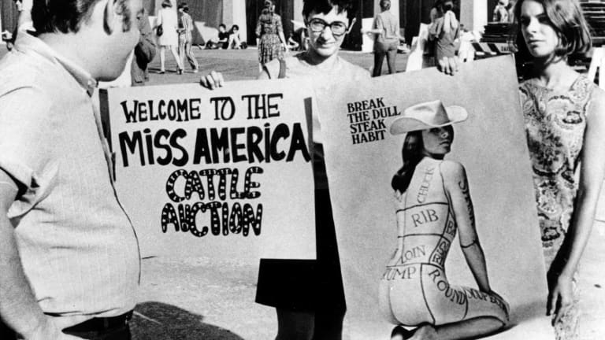

Around 200 feminist demonstrators gathered outside the Miss America Contest in September 1968 to protest sexism and the shallow commodification of the female body. Posters like this one drew worldwide attention to the Women’s Liberation Movement.

**WEEK 2. Liberating the Masses**

Monday: The “Modern” Family

* No reading; in-class viewing of *Penny Serenade* (1941)

Tuesday: Baby Boomin’

* “Model Mothers” (1942)
* Self, chap. 5

Wednesday: “Yes”

* Self, Chapter 7
* Robin Morgan, “Goodbye to All That”
* Helen Gurley Brown, *Sex and the Single Girl* (excerpts)

Thursday: Sing Freedom

* Thomas Smith, “Civil Rights on the Gridiron,” *Journal of Sport History*
* Lyndon Johnson, Commencement Address at Howard University (1965)
* Malcolm X, The Ballot or the Bullet (1964)

Friday: Fixin’-to-Die

* Self, Chapter 3
* Paul Potter on the Anti-War Movement (1965)
* John Kerry, VVAW statement before Congress (1971)

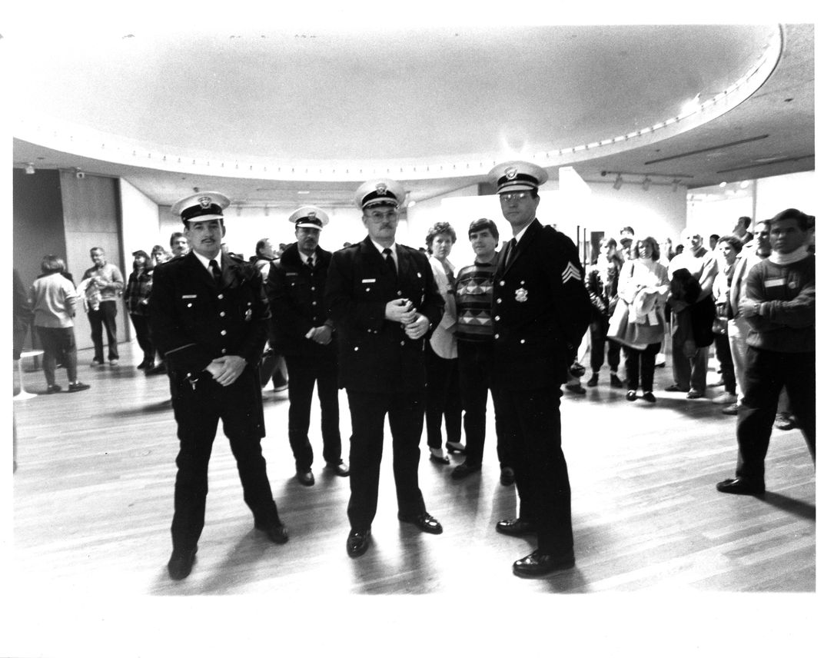

When Dennis Barrie, the director of the Contemporary Arts Center in Cincinnati, opened an exhibit featuring sexually explicit art by Robert Mapplethorpe, the police showed up. They temporarily closed the exhibit to collect “evidence” about whether the government should fund artwork deemed obscene. The episode was but one of many in the so-called “Culture Wars” of the 1990s

**WEEK 3. Age of Fracture**

Monday: Morning Hair

* Betty Friedan, The Feminist Mystique (1963, excerpts)
* Andrea Dworkin, “Morning Hair” (1967)
* Self, chap. 4 and 6
* Gloria Steinem, “A New Egalitarian Life Style” (1971)
* Patricia Coffin, “Memo to the American Woman” (1966)

Tuesday: Why People Started Jogging

* Tom Wolfe, “The ‘Me’ Decade” (1976)
* Gary Dahl, Pet Rock ad
* Christopher Lasch, *The Culture of Narcissism* (1979, excerpts)
* Self, chap. 8

Wednesday: God and Walmart

* Self, chap. 10 and 12
* Marabel Morgan interview with Phyllis Schlafly on the ERA (1978)
* Jerry Falwell, “Listen America!” (1980)
* Chicago Declaration of Evangelical Social Concern (1973)
* Pat Robertson, “Organizing the Moral Majority” (1980)

Thursday: For the Soul of America

* James Davidson Hunter, *Culture Wars: The Struggle to Define America* (excerpts)
* Pat Buchanan, “The Cultural War for the Soul of America” (1992)
* Self, chap. 13 and epilogue

Friday: Netflix and Chill

* Neil Postman, *Amusing Ourselves to Death* (1985, excerpts)
* “How Teens Use Social Media”
* “Why Kids Sext”
* “Is Facebook Making Us Lonely?”

**WEEK 4: It’s the Final Countdown**

Monday: Social Biography Presentations

* No readings

Tuesday: Exam Prep

* No readings

Wednesday: FINAL EXAM

* Social Biography due